Date :- 03-06-2026
Name :- Neha Kadam

- Task 1 : Create an HTML program that demonstrates the use of block-level elements

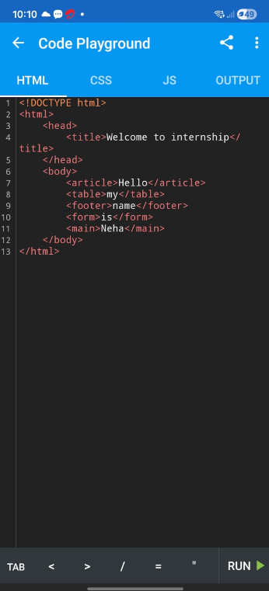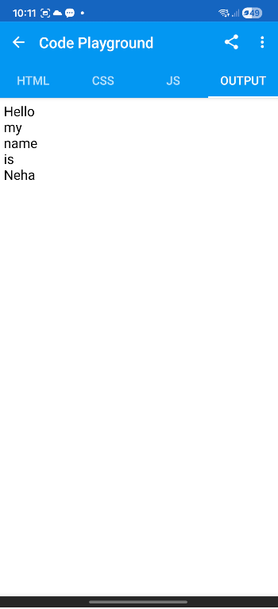
- Task 2: Create an HTML program that demonstrates the use of inline elements.

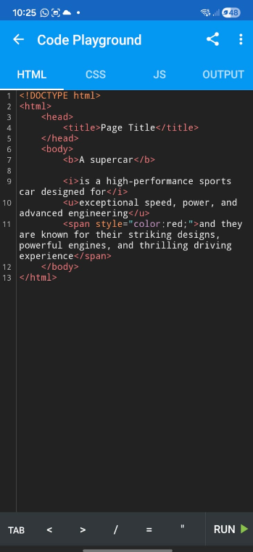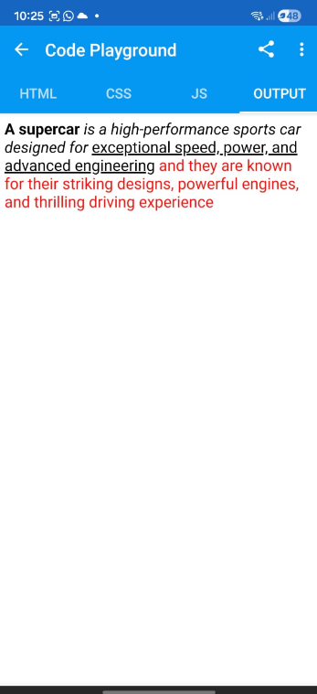

TASK 3: Create a simple Resume webpage using both block and inline elements. Include the following sections:
* Full Name *Technical Skills
*Contact Information *Projects
*Career Objective *Hobbies
*Educational Details *Declaration

